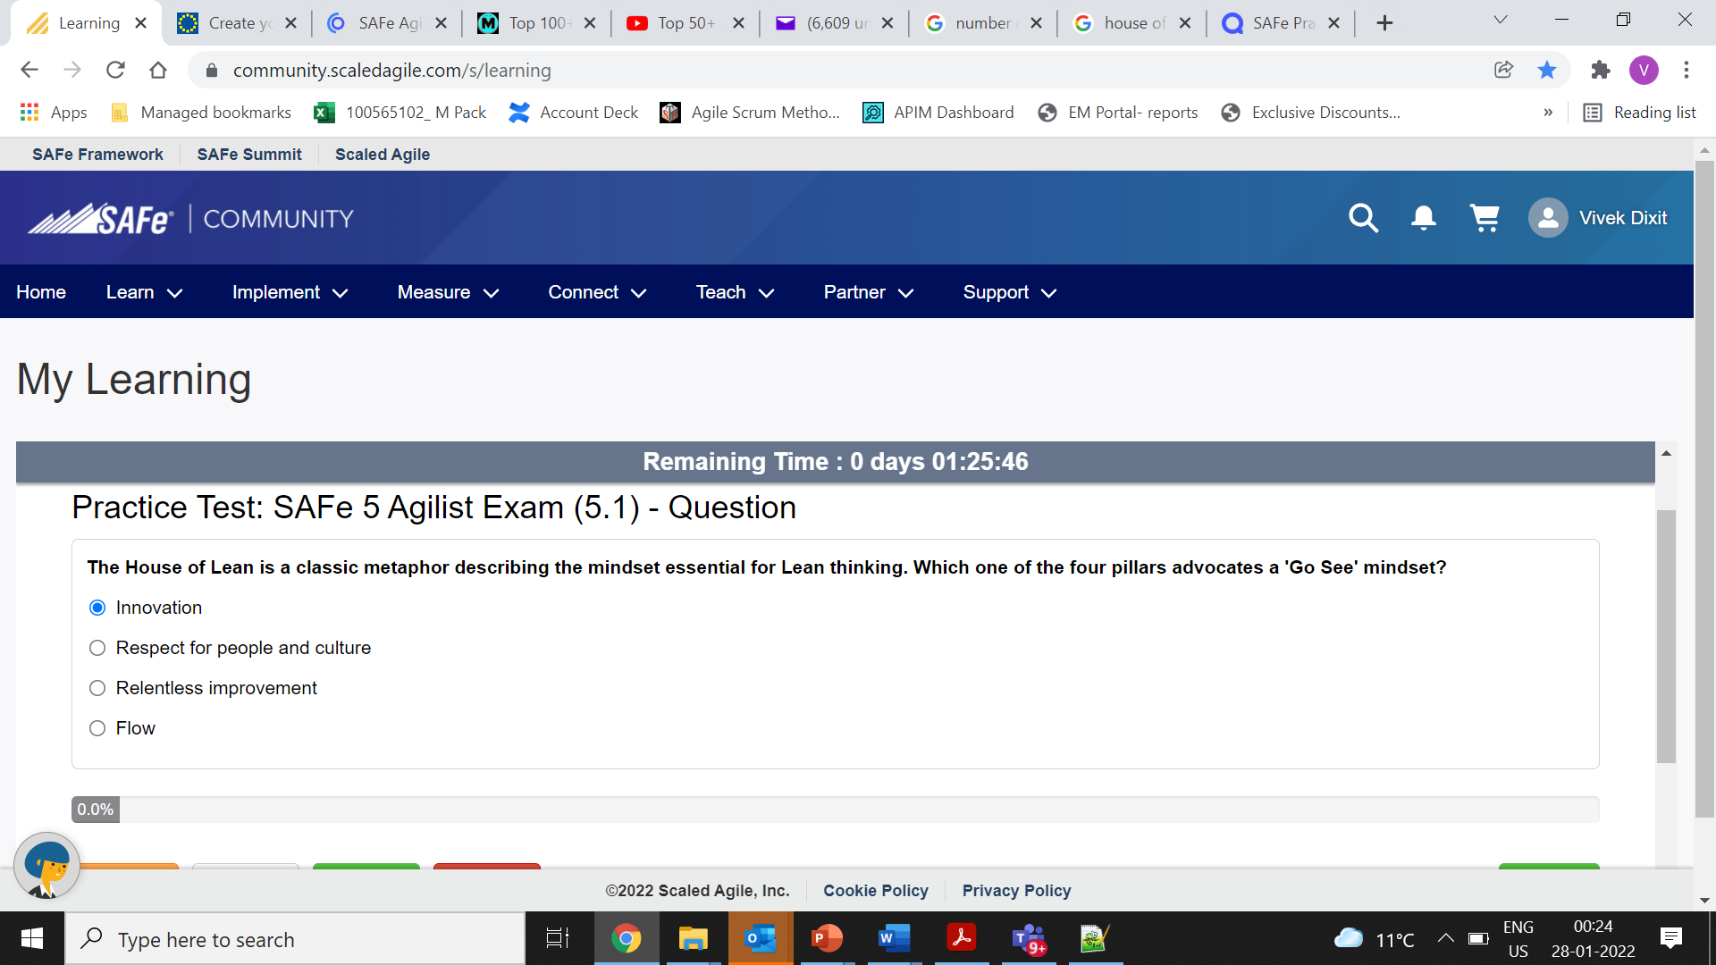

correct

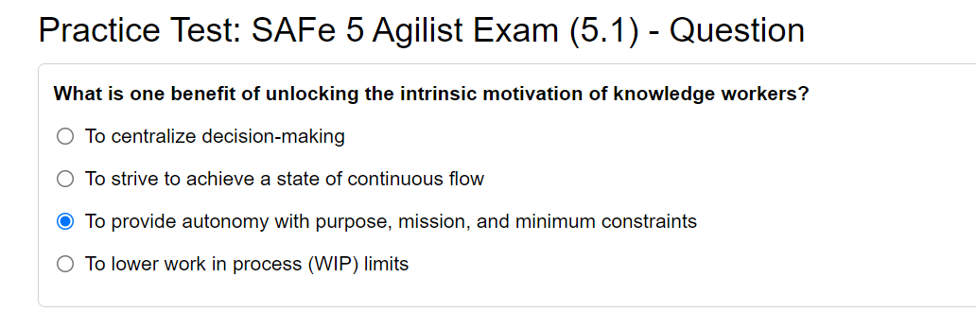

correct

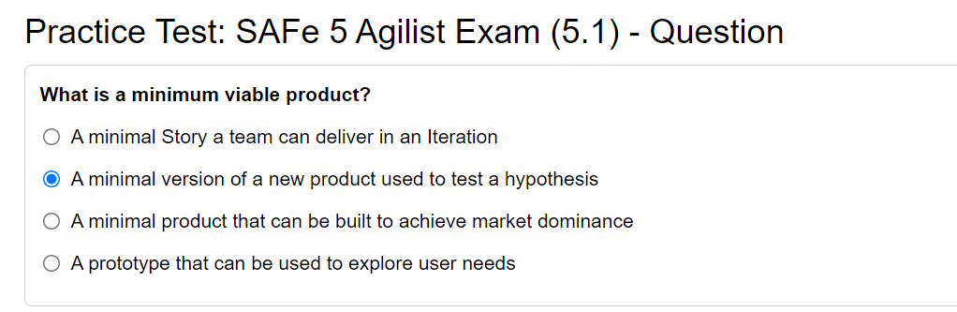

correct

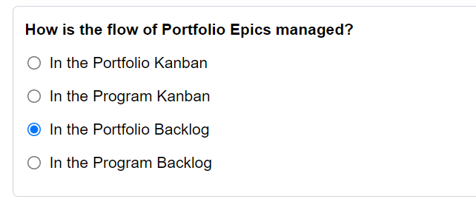

Wrong – Portfolio Kanban

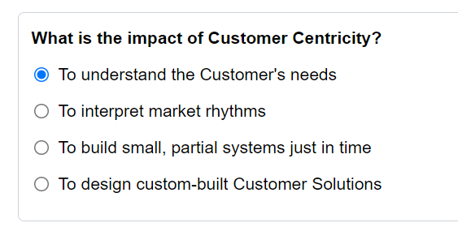

Correct

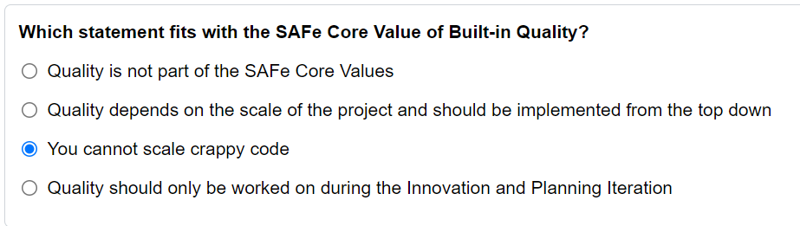

correct

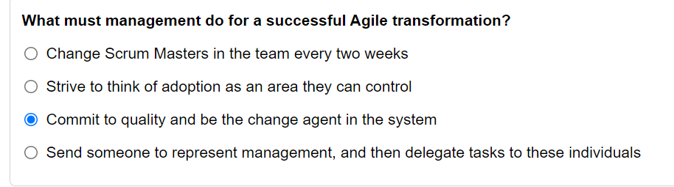

correct

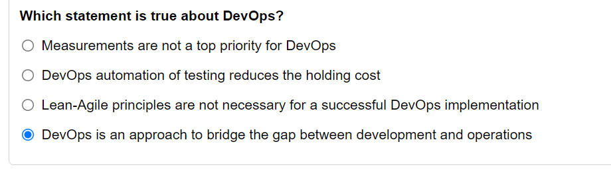

Correct

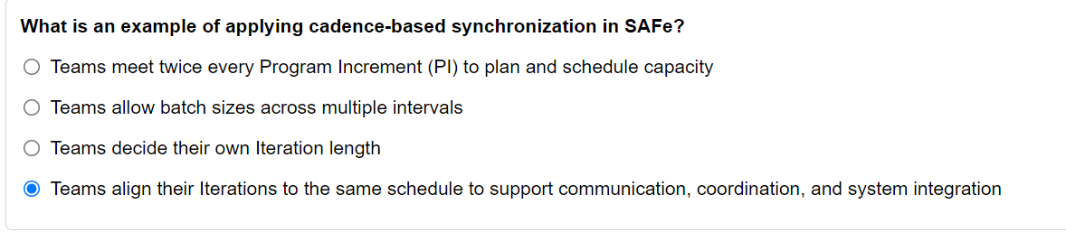

Correct

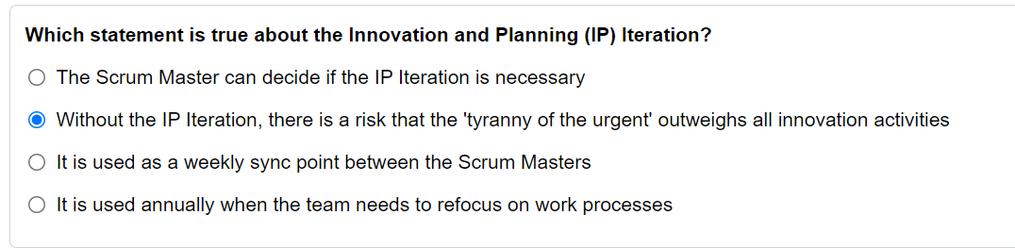

Correct

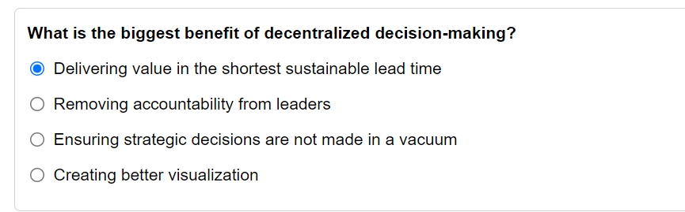

Correct

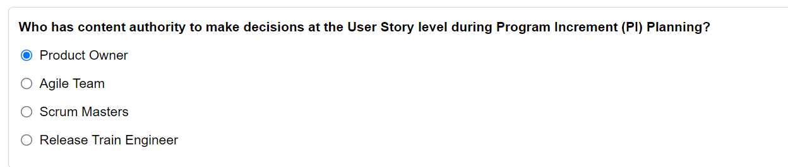

Correct

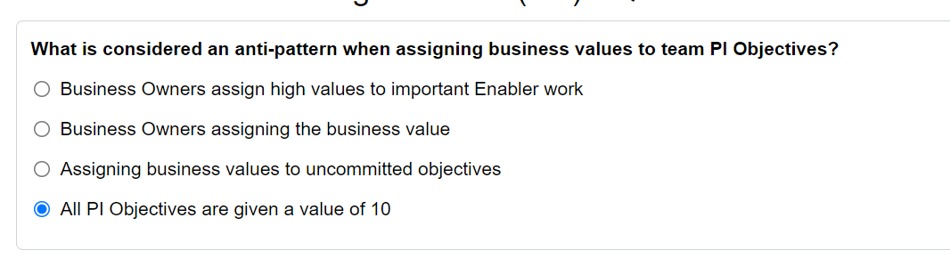

Correct

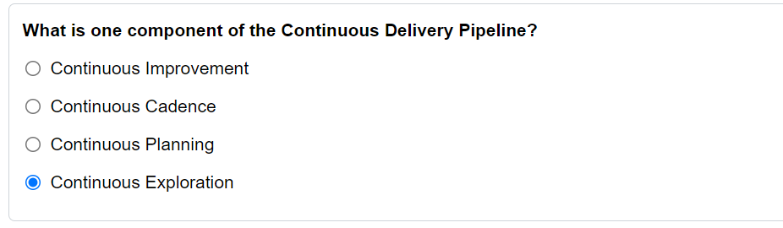

Correct

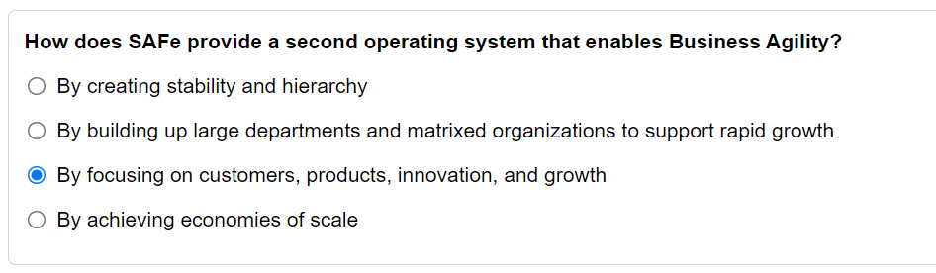

Correct

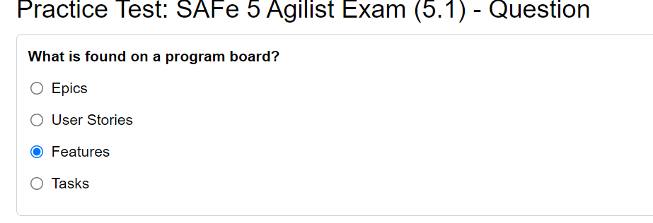

Correct

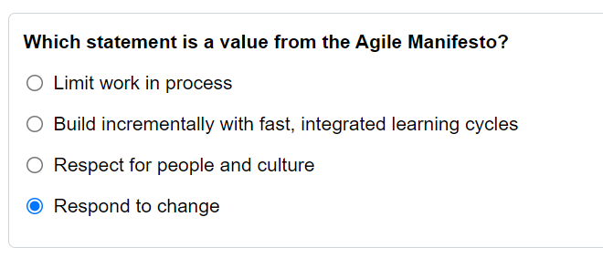

Correct

Tukka - Correct

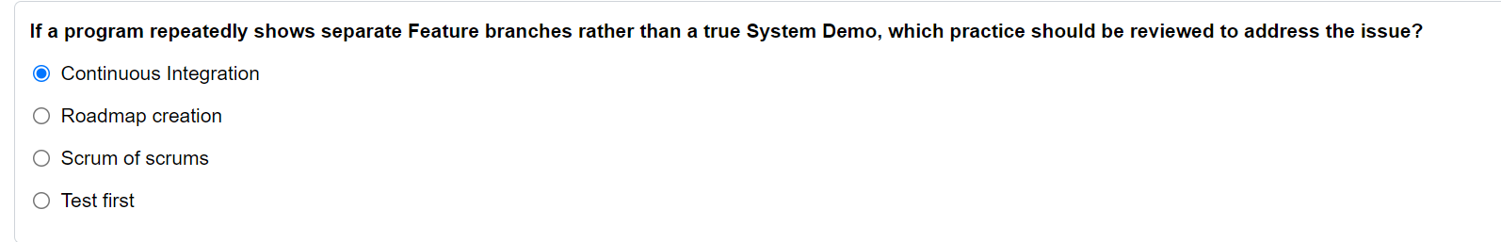

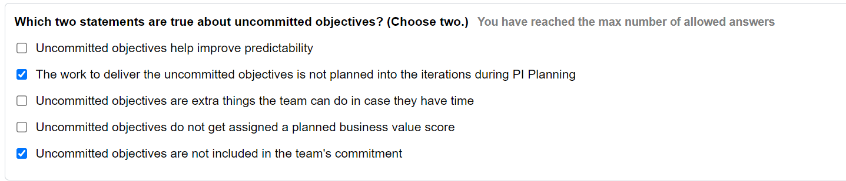

Wrong: TBF

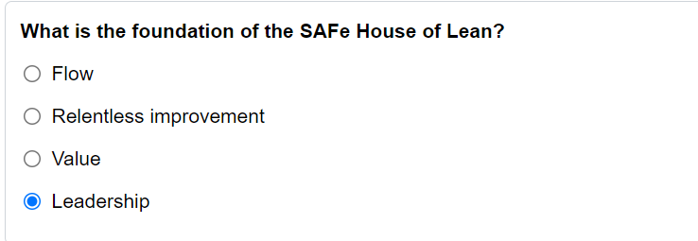

Correct

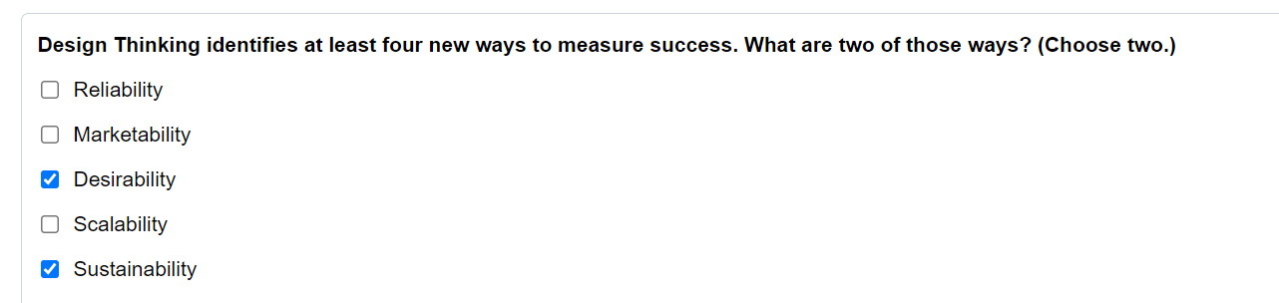

Correct

Tukka - Sahi

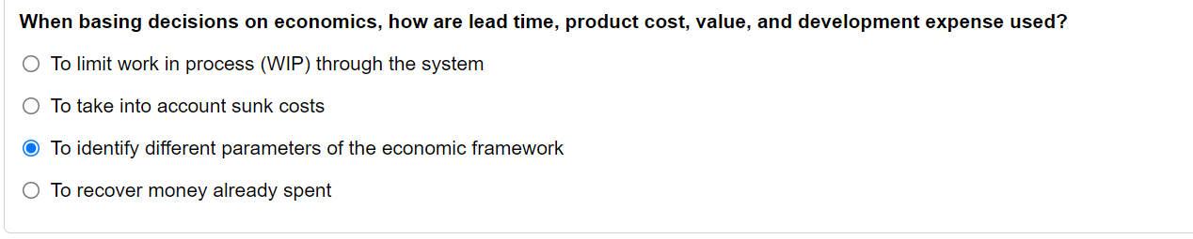

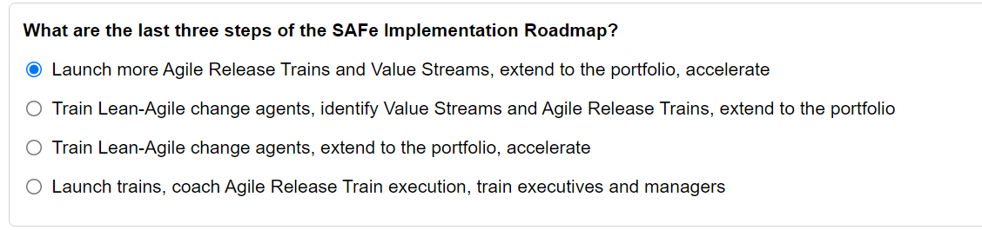

Correct

Tukka: Sahi

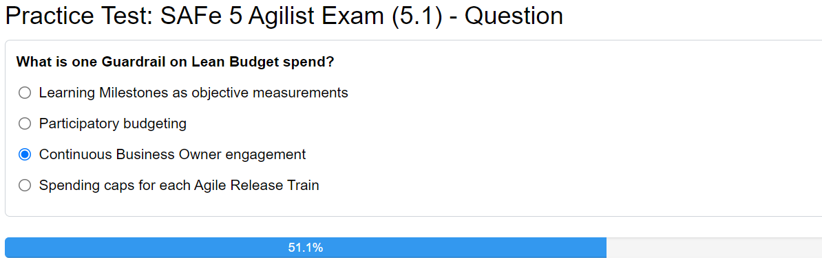

Tukka: Wrong- Anchor new approach into Culture

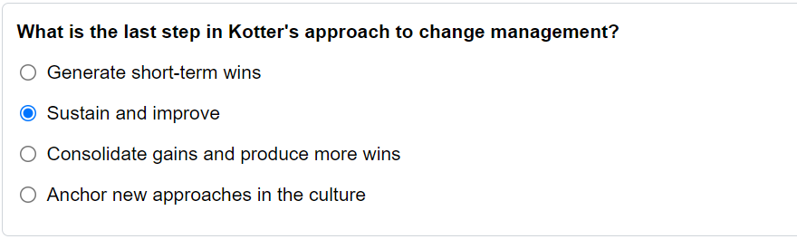

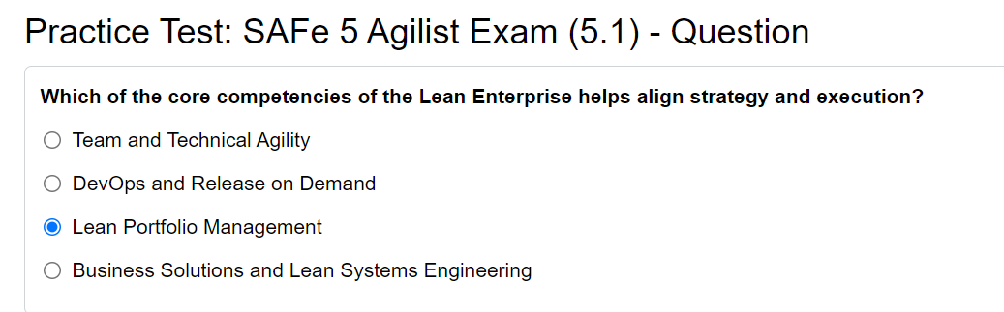

Correct

Tukka: Sahi

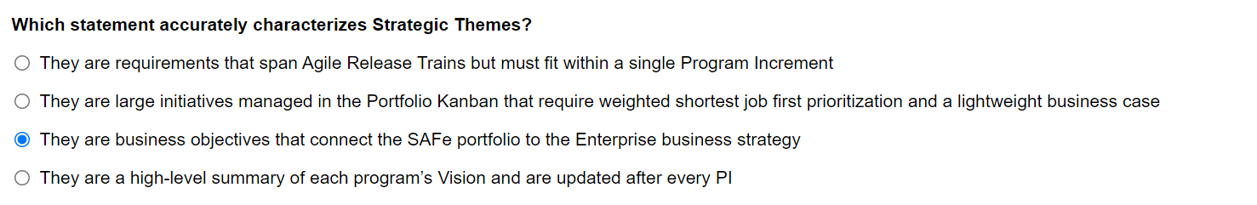

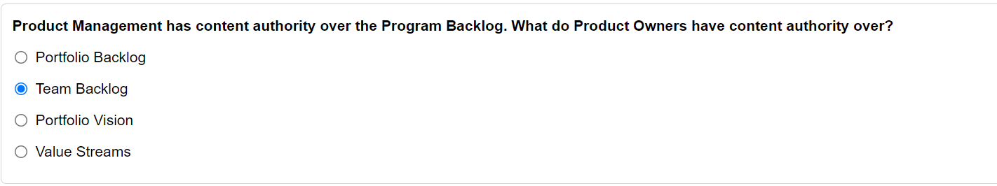

Correct

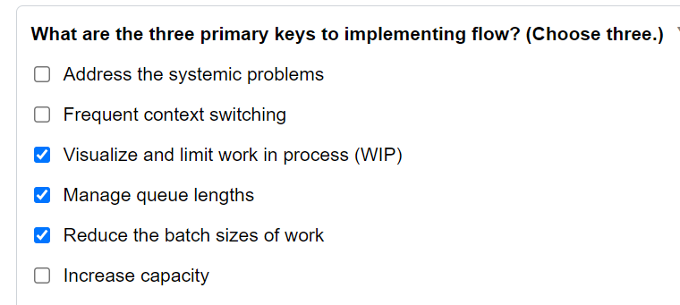

Correct

Tukka: Sahi

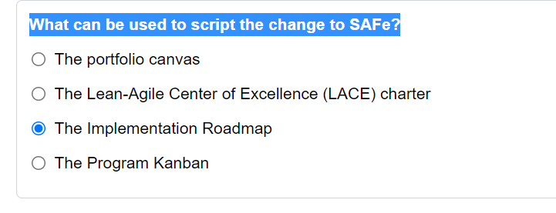

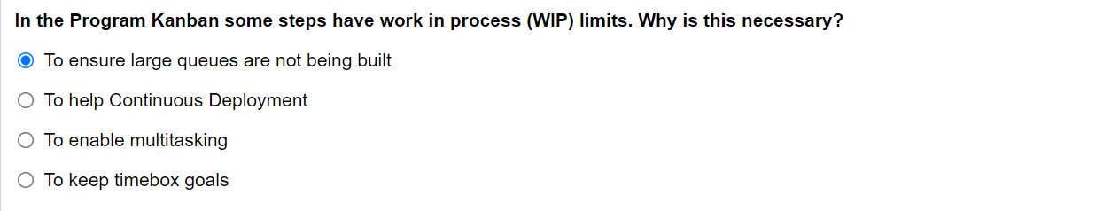

Correct

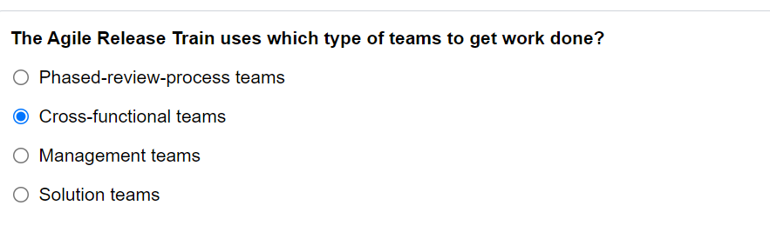

Correct

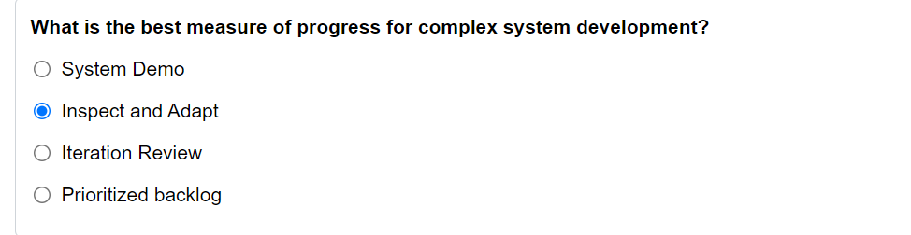

Wrong: System Demo

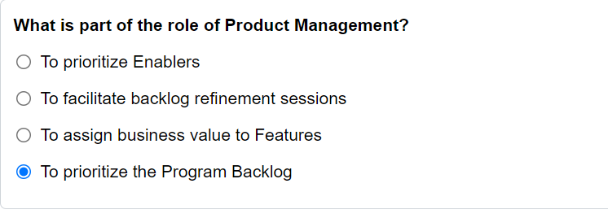

Correct

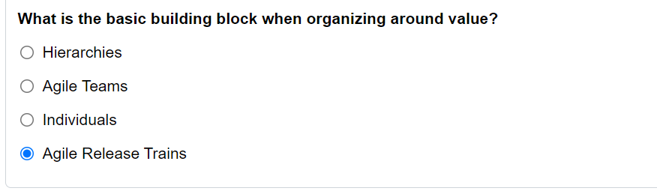

Wrong: Agile Teams

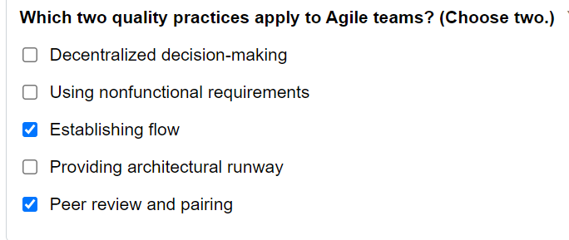

Correct

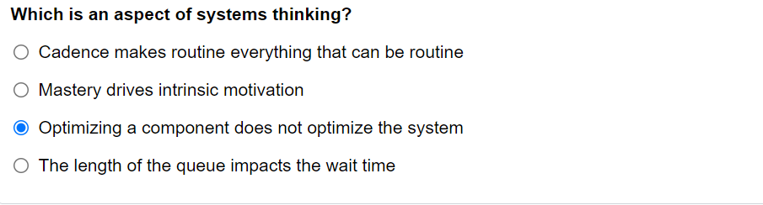

Correct

Tukka: Sahi

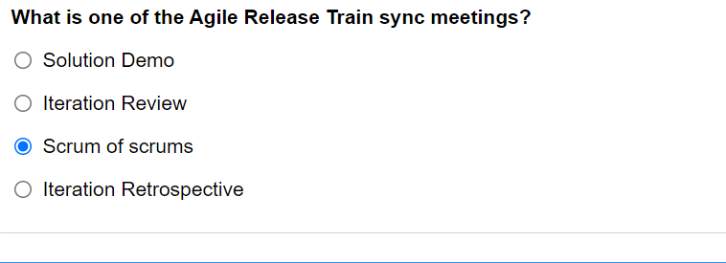

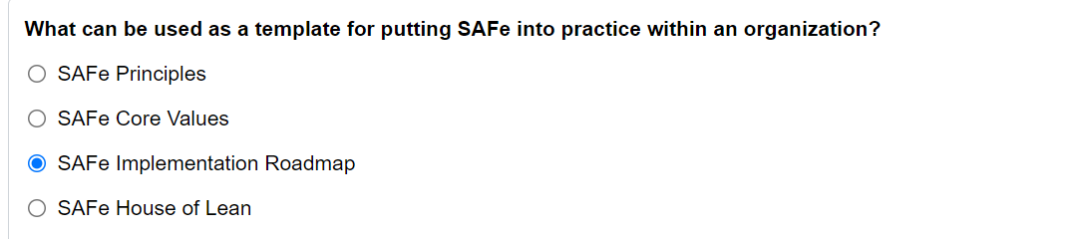

Correct

Tukka: Sahi

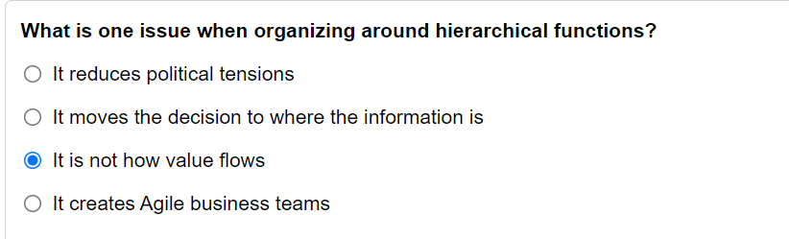

Tukka: Sahi

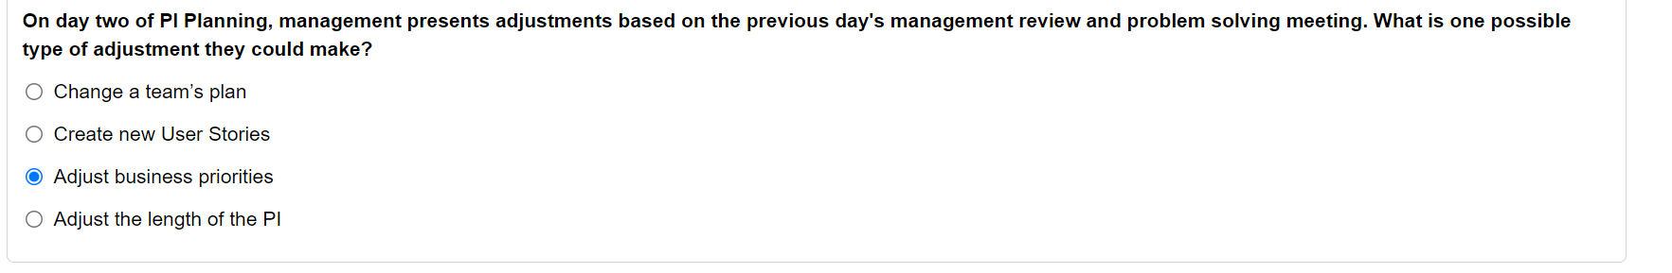

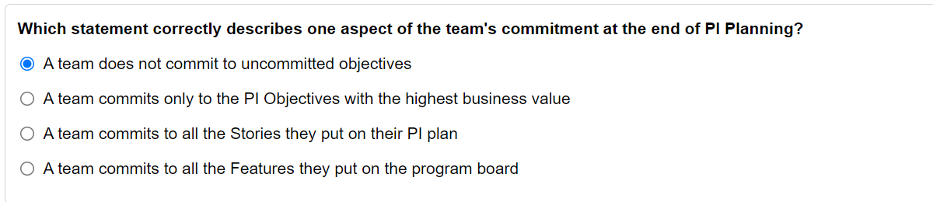

Correct

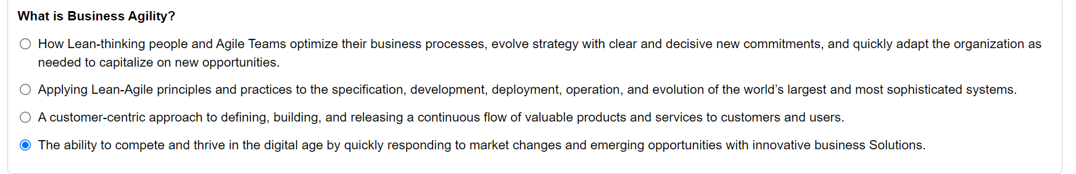

Correct

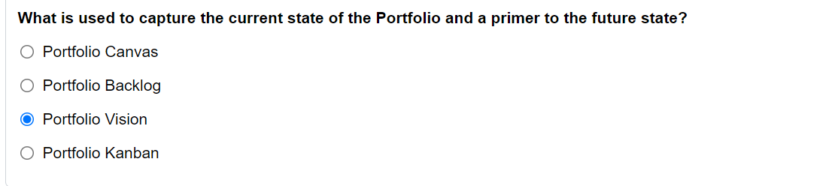

Wrong: Portfolio Canvas

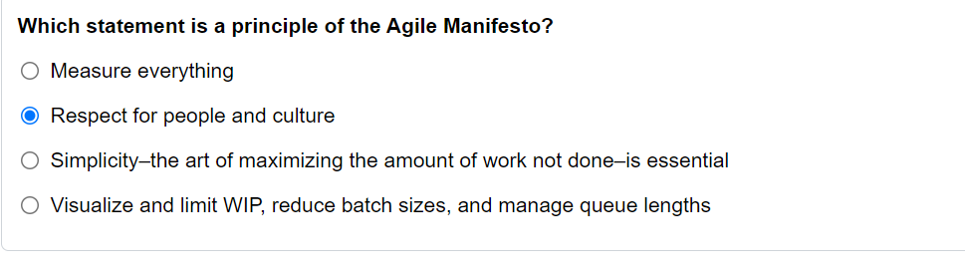

Wrong: Simplicity

Top of Form

| **Response Summary** | |
| --- | --- |
| Question | |
| What must management do for a successful Agile transformation? | Commit to quality and be the change agent in the system |
| Question | |
| How does SAFe provide a second operating system that enables Business Agility? | By focusing on customers, products, innovation, and growth |
| Question | |
| What is Business Agility? | The ability to compete and thrive in the digital age by quickly responding to market changes and emerging opportunities with innovative business Solutions. |
| Question | |
| What are the last three steps of the SAFe Implementation Roadmap? | Launch more Agile Release Trains and Value Streams, extend to the portfolio, accelerate |
| Question | |
| What can be used as a template for putting SAFe into practice within an organization? | SAFe Implementation Roadmap |
| Question | |
| Which of the core competencies of the Lean Enterprise helps align strategy and execution? | Lean Portfolio Management |
| Question | |
| What is the foundation of the SAFe House of Lean? | Leadership |
| Question | |
| The House of Lean is a classic metaphor describing the mindset essential for Lean thinking. Which one of the four pillars advocates a 'Go See' mindset? | Innovation |
| Question | |
| Which statement fits with the SAFe Core Value of Built-in Quality? | You cannot scale crappy code |
| Question | |
| Which statement is a value from the Agile Manifesto? | Respond to change |
| Question | |
| Which statement is a principle of the Agile Manifesto? | Respect for people and culture |
| Question | |
| When basing decisions on economics, how are lead time, product cost, value, and development expense used? | To identify different parameters of the economic framework |
| Question | |
| Which is an aspect of systems thinking? | Optimizing a component does not optimize the system |
| Question | |
| What are the three primary keys to implementing flow? (Choose three.) | Visualize and limit work in process (WIP);Manage queue lengths;Reduce the batch sizes of work; |
| Question | |
| What is an example of applying cadence-based synchronization in SAFe? | Teams align their Iterations to the same schedule to support communication, coordination, and system integration |
| Question | |
| What is one benefit of unlocking the intrinsic motivation of knowledge workers? | To provide autonomy with purpose, mission, and minimum constraints |
| Question | |
| What is the biggest benefit of decentralized decision-making? | Delivering value in the shortest sustainable lead time |
| Question | |
| What is the basic building block when organizing around value? | Agile Release Trains |
| Question | |
| What is one issue when organizing around hierarchical functions? | It is not how value flows |
| Question | |
| The Agile Release Train uses which type of teams to get work done? | Cross-functional teams |
| Question | |
| Product Management has content authority over the Program Backlog. What do Product Owners have content authority over? | Team Backlog |
| Question | |
| What is part of the role of Product Management? | To prioritize the Program Backlog |
| Question | |
| Which two quality practices apply to Agile teams? (Choose two.) | Establishing flow;Peer review and pairing; |
| Question | |
| Design Thinking identifies at least four new ways to measure success. What are two of those ways? (Choose two.) | Desirability;Sustainability; |
| Question | |
| What is the impact of Customer Centricity? | To understand the Customer's needs |
| Question | |
| Which statement correctly describes one aspect of the team's commitment at the end of PI Planning? | A team does not commit to uncommitted objectives |
| Question | |
| Which two statements are true about uncommitted objectives? (Choose two.) | The work to deliver the uncommitted objectives is not planned into the iterations during PI Planning;Uncommitted objectives are not included in the team's commitment; |
| Question | |
| What is considered an anti-pattern when assigning business values to team PI Objectives? | All PI Objectives are given a value of 10 |
| Question | |
| On day two of PI Planning, management presents adjustments based on the previous day's management review and problem solving meeting. What is one possible type of adjustment they could make? | Adjust business priorities |
| Question | |
| What is found on a program board? | Features |
| Question | |
| Who has content authority to make decisions at the User Story level during Program Increment (PI) Planning? | Product Owner |
| Question | |
| In the Program Kanban some steps have work in process (WIP) limits. Why is this necessary? | To ensure large queues are not being built |
| Question | |
| What is one of the Agile Release Train sync meetings? | Scrum of scrums |
| Question | |
| Which statement is true about the Innovation and Planning (IP) Iteration? | Without the IP Iteration, there is a risk that the 'tyranny of the urgent' outweighs all innovation activities |
| Question | |
| What is one component of the Continuous Delivery Pipeline? | Continuous Exploration |
| Question | |
| Which statement is true about DevOps? | DevOps is an approach to bridge the gap between development and operations |
| Question | |
| If a program repeatedly shows separate Feature branches rather than a true System Demo, which practice should be reviewed to address the issue? | Continuous Integration |
| Question | |
| What is the best measure of progress for complex system development? | Inspect and Adapt |
| Question | |
| What is used to capture the current state of the Portfolio and a primer to the future state? | Portfolio Vision |
| Question | |
| Which statement accurately characterizes Strategic Themes? | They are business objectives that connect the SAFe portfolio to the Enterprise business strategy |
| Question | |
| What is a minimum viable product? | A minimal version of a new product used to test a hypothesis |
| Question | |
| How is the flow of Portfolio Epics managed? | In the Portfolio Backlog |
| Question | |
| What is one Guardrail on Lean Budget spend? | Continuous Business Owner engagement |
| Question | |
| What is the last step in Kotter's approach to change management? | Sustain and improve |
| Question | |
| What can be used to script the change to SAFe? | The Implementation Roadmap |

Bottom of Form

| **Topic Summary** | |
| --- | --- |
| Thriving in the Digital Age with Business Agility |  |
| Becoming a Lean-Agile Leader |  |
| Establishing Team and Technical Agility |  |
| Building Solutions with Agile Product Delivery |  |
| Exploring Lean Portfolio Management |  |
| Leading the Change |  |